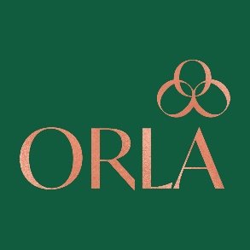

Returns Form

If you would like to make a return please follows the following steps:

1. Please notify us within 7 days of receiving your item if you would like to make a return. Please use the following email orla@orladunlea.ie

2. Please pack and return your item(s) in their original an unused condition along with this returns form to the address below within 28 days of receiving your delivery.

3. Please obtain your proof of postage. On the safe arrival of your return we will process a refund for the cost of the item.

If your item has arrived damaged or faulty:
Please email orla@orladunlea.ie within 24 hours of receiving your delivery. Please include photos of the damage or fault.

NAME:

ORDER NUMBER:

ITEM(S) YOU ARE RETURNING:

REASON FOR RETURN:

Return Address: 23 Hollybank Avenue Lower, Dublin 6, County Dublin, D06 Y9Y8, Ireland

